**Spring Security Demo (on JSP and @Controller)**

1. Connect to this URL to get the List of Specialization:

<http://localhost:8080/SpringMVCDemo/norest/Specialization>

1. Connect to this URL to get the List of Student:

<http://localhost:8080/SpringMVCDemo/norest/Student>

1. This application will redirect user to the Log-in Page if they did not log in (Accounts are stored in the Users Table).

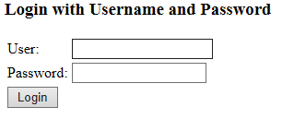

**Spring Security Demo (on @RestController)**

1. Send a POST request like the picture below to get the access token:

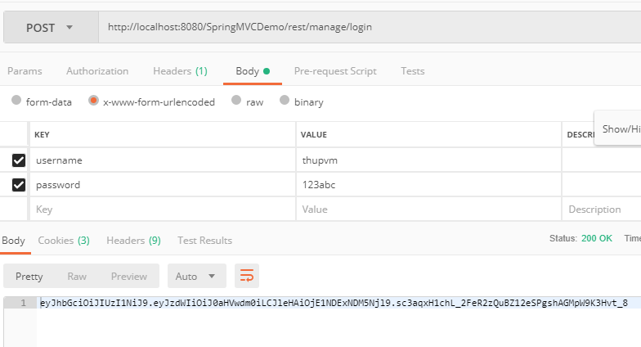

1. Copy the access token before the prefix “Bearer “ to Header/ Authorization of some requests like some picture below:

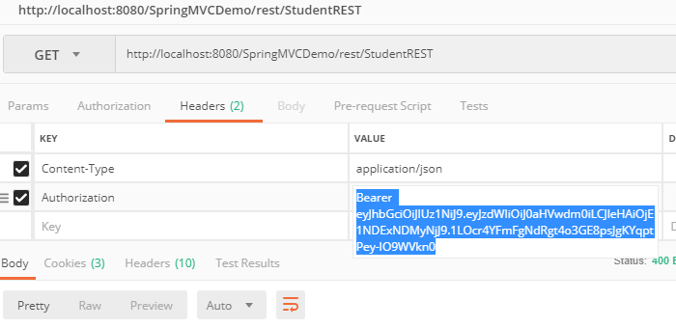

If user’s token is valid, the api will return JSON of data.

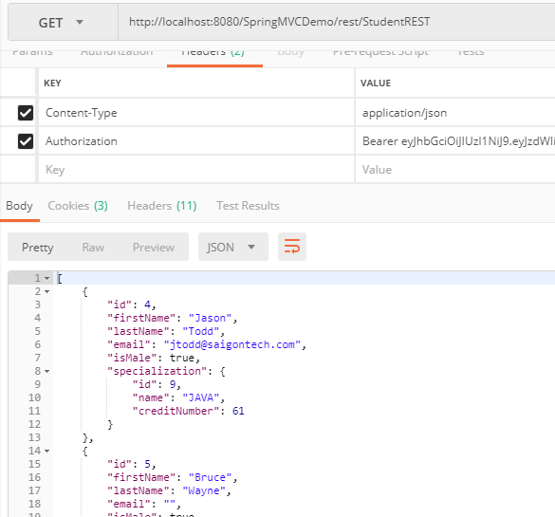

If user do not have Header Authorization, the API will return

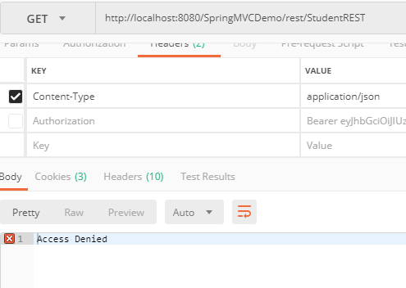

If user’s token is expired (over 2 minutes). The API will return

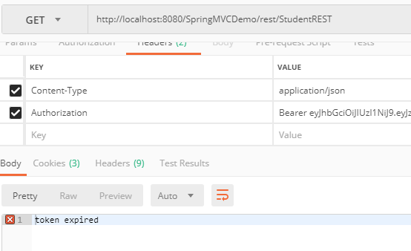

If user’s token is wrong. The API will return:

